Hello and welcome to Hardware: It’s not just for EE’s anymore!

In this class we explore hacking together custom built hardware and off the shelf hardware. Normally we use a “solderless breadboard” to wire together circuits, checking out basic functions.

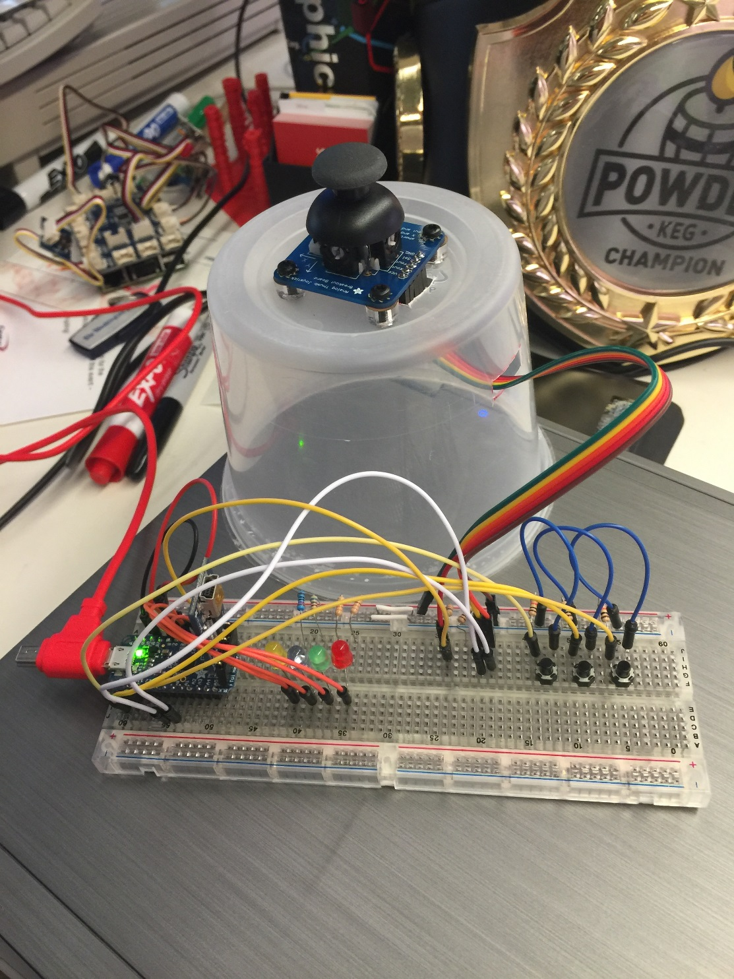

This is OK and we can do a lot of work quickly to try out an idea. There comes a time however when we spend more time mending wires that come loose then we spend debugging code. That is the time we translate the circuit onto a printed circuit board (PCB). Using free software from ExpressPCB, Fritzing or Eagle, you can create a logical diagram (schematic) of the physical wires you put together on the breadboard. Here is an example of an early prototype using a Fritzing application to diagram the circuit and the actual circuit built using a solderless breadboard:  
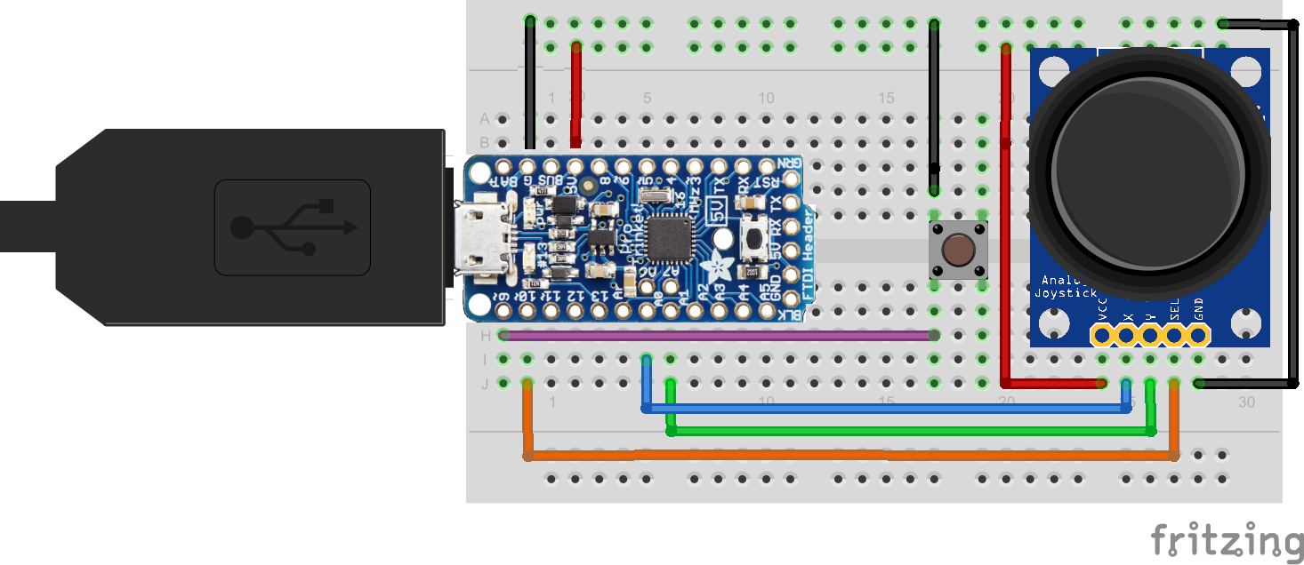  
Once you work out the code, a printed circuit board can be designed 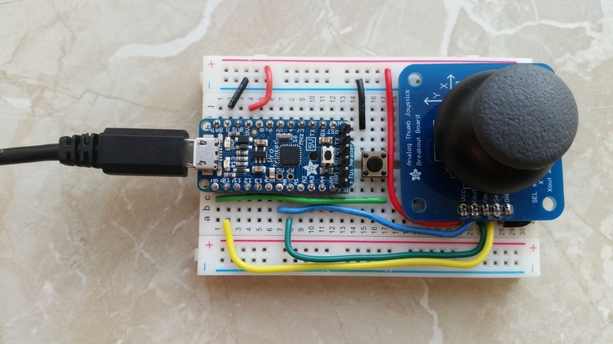

Once the circuit has been debugged, you can design a circuit to be laid out on a printed circuit board (PCB).

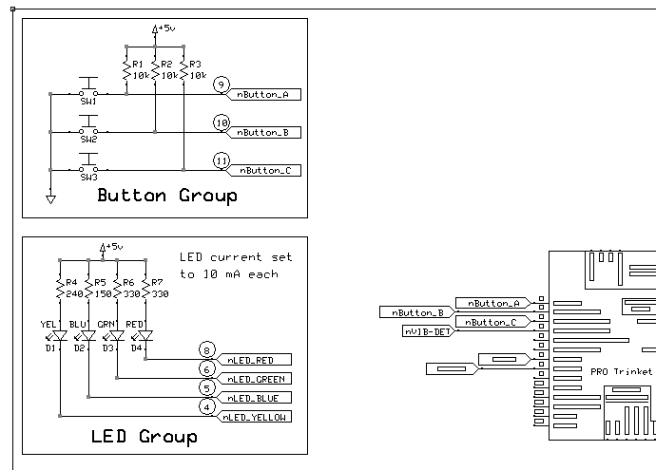

This schematic describes the logical connections between physical components. The PCB layout places the physical connections to realize the design:  
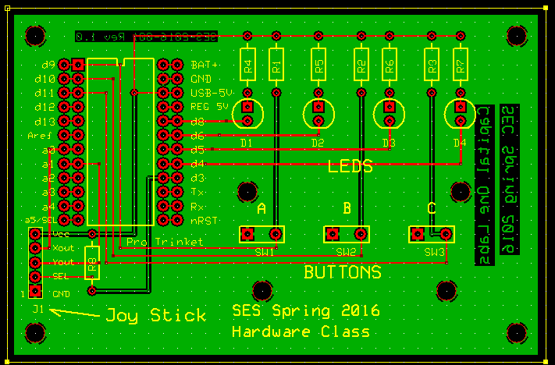

Next - the PCB is assembled by soldering the components into the spaces and holes provided to complete the board:

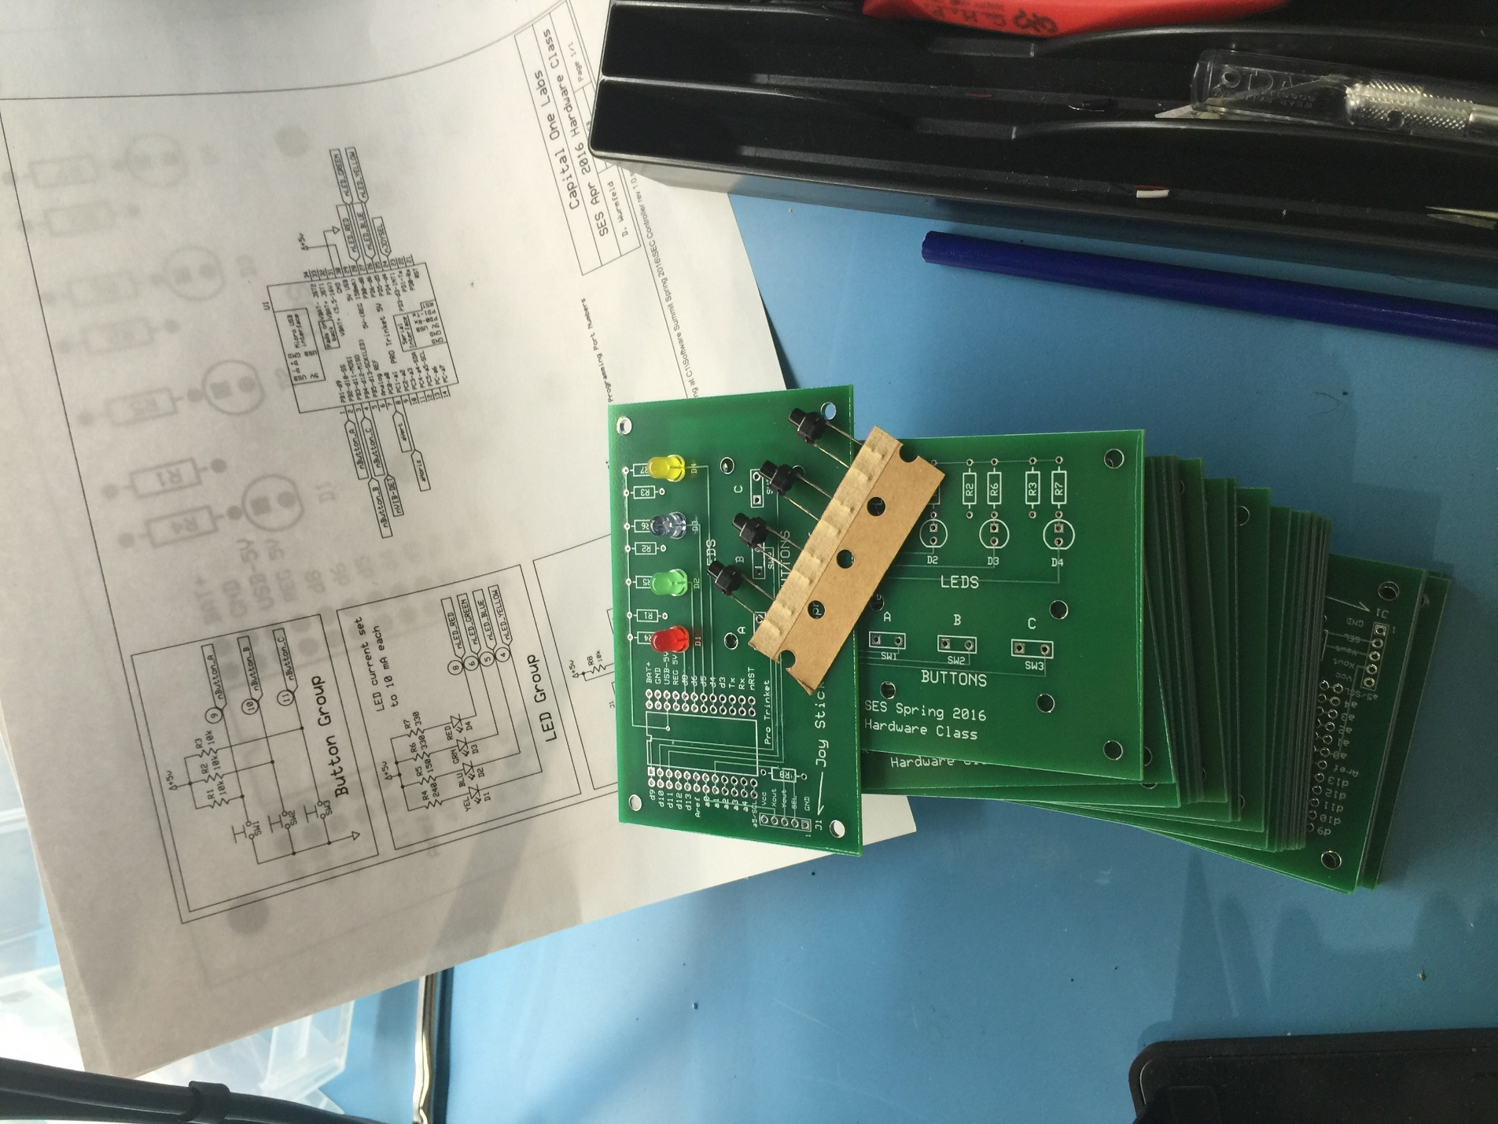

Finally, we can design mechanical enclosures to make our idea complete:

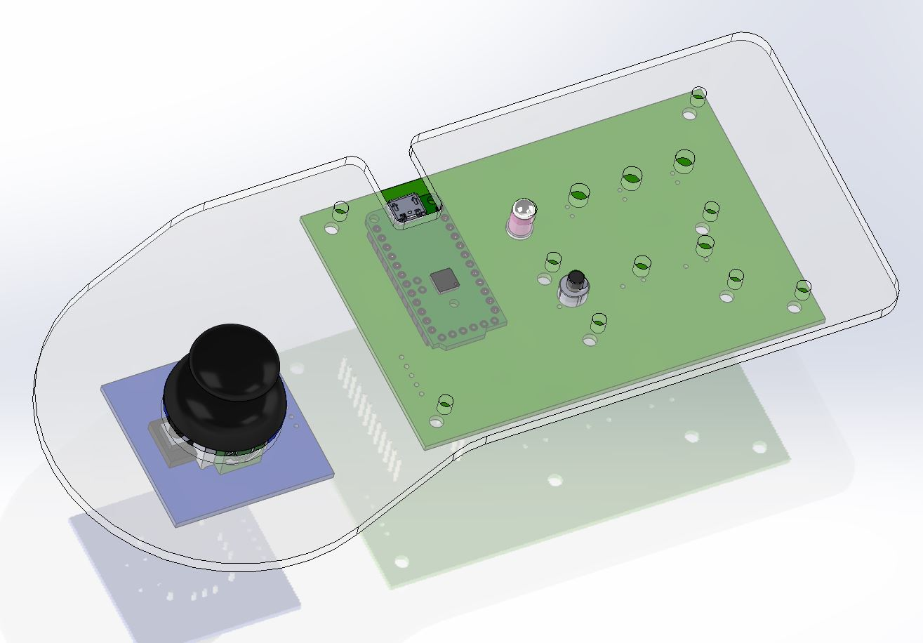

As we will demonstrate in class, it is not magic to do any one of these pieces, you just need to develop e “tool box” of tacit knowledge – skills – that can be used in any combination to successfully conceive, design, prototype and make almost anything.